sWEEK 6 – PRODUCT REVIEW AND RATING MANAGEMENT SYSTEM
Scenario:
An e-commerce company wants to develop a Product Review and Rating Management System to collect customer feedback about purchased products. Customers can give ratings from 1 to 5 stars and write reviews about products. The system stores customer reviews, updates or delete reviews when necessary, calculates average ratings, and identifies highly rated products. These reports help the company understand customer satisfaction and improve product quality.
Create Review and Rating Table:
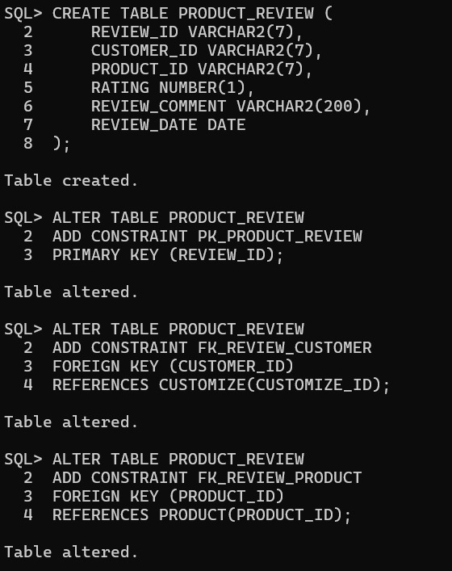
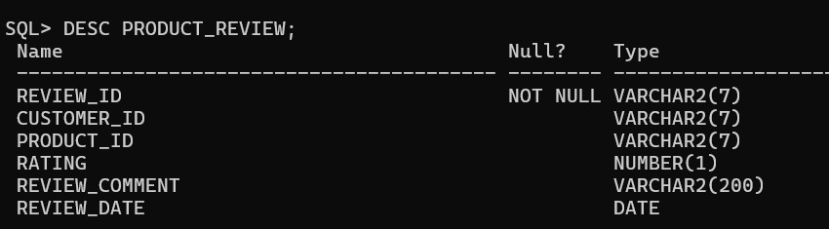

Insert Customer Reviews:

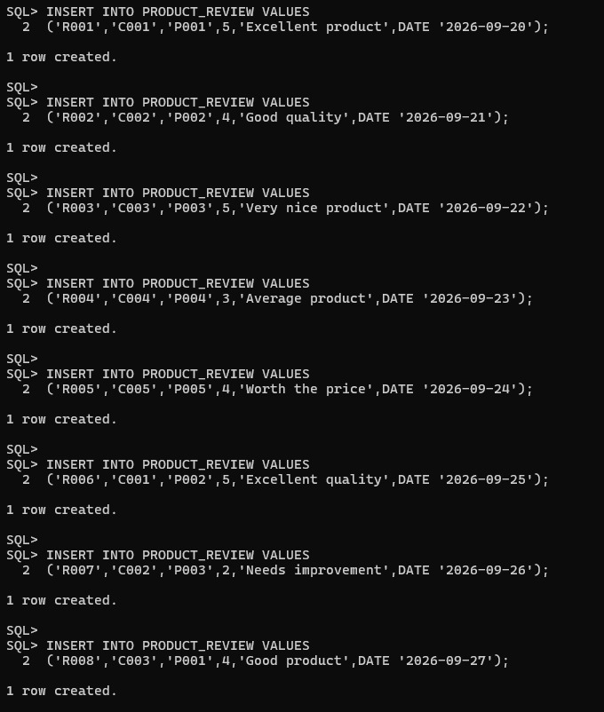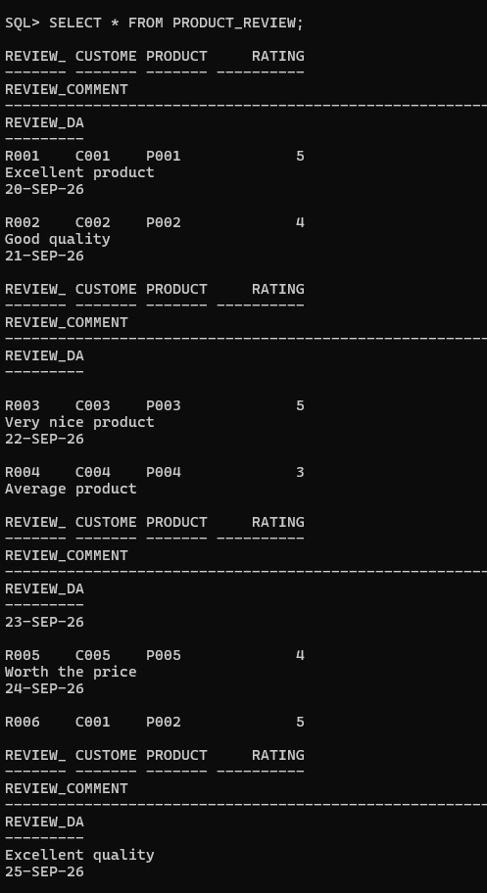
Check:
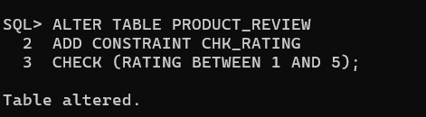
Update and Delete Reviews:
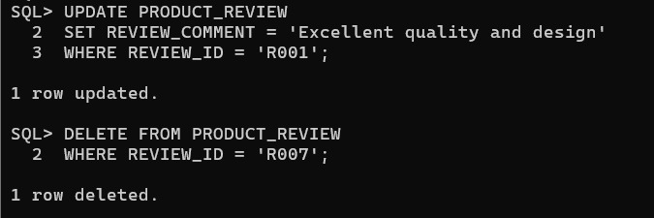
Retrieve Product Review Details
Display All Reviews:
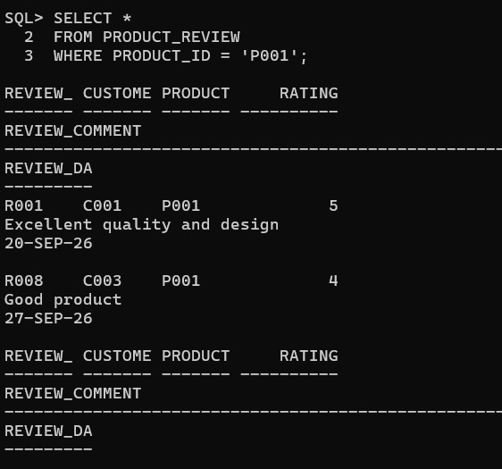

Display Customer Names with Reviews:
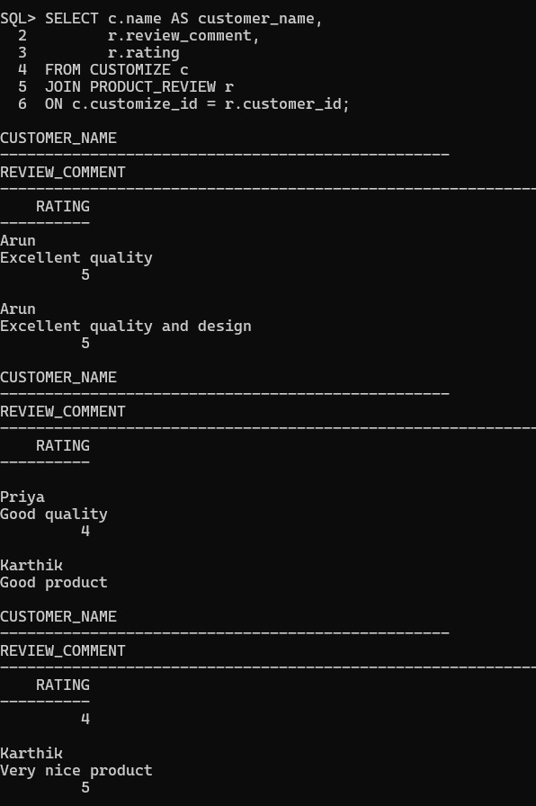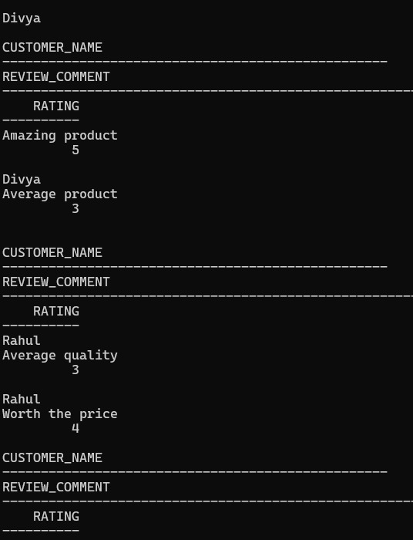
Find Products Having Maximum Reviews:
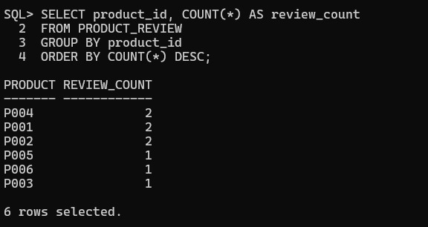
Display Recent Customer Feedback:
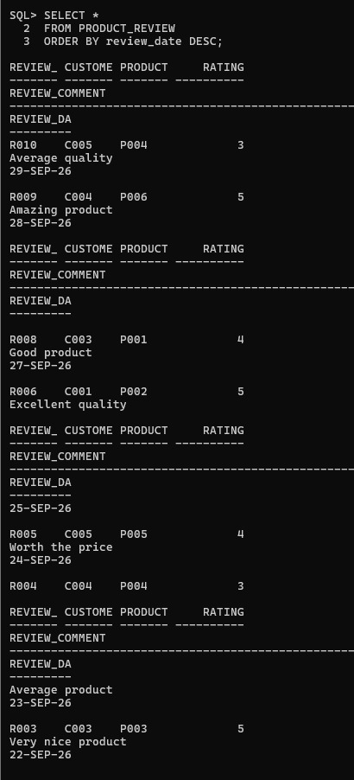
Retrieve Reviews with Ratings Above 4:
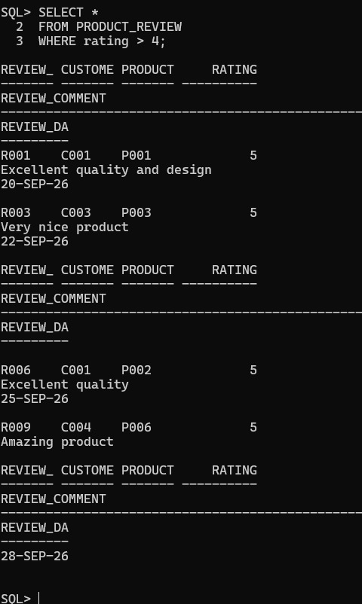
Calculate Average Product Ratings
Average Rating for Each Product:
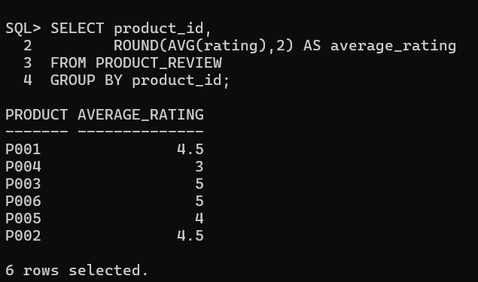
Count Reviews per Product:
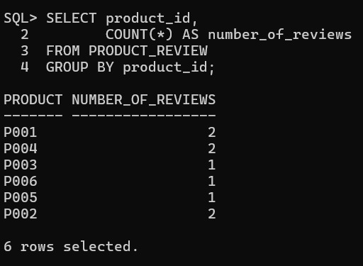
Find Highest-Rated Products:
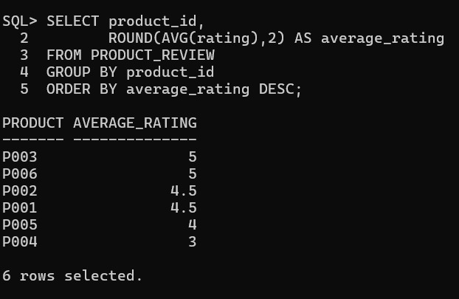
Products with Average Rating Above 4:
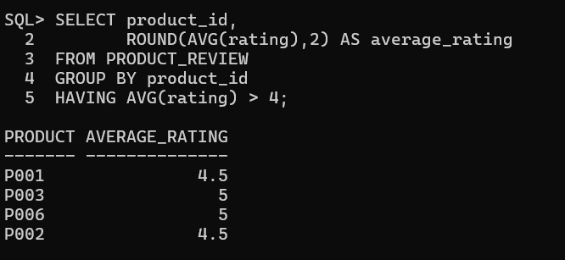

Report 1: Product Rating Analysis
Display the product ID, number of reviews and average rating.
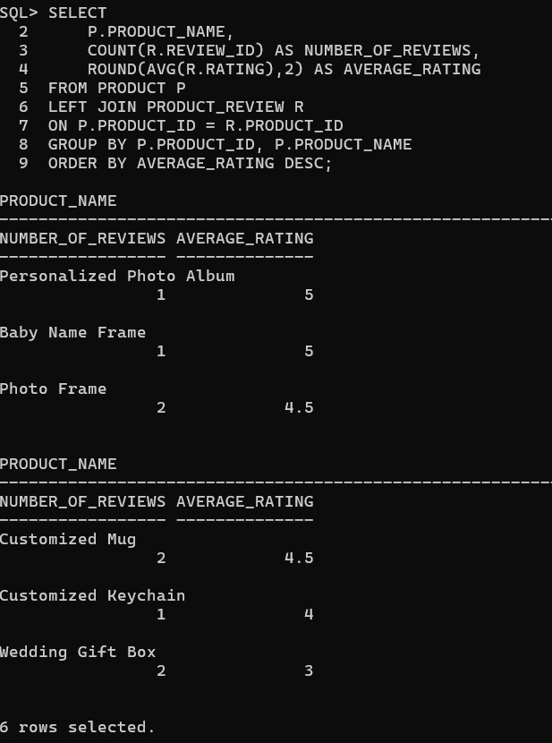
Report 2: Customer Feedback Analysis
Most reviewed products:
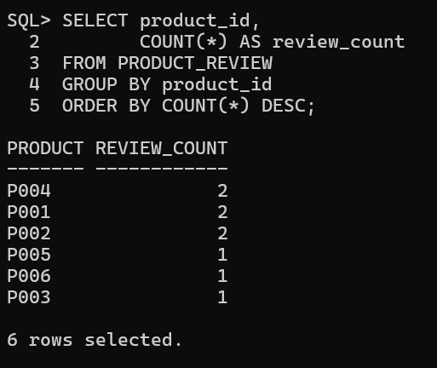
Highly rated products:
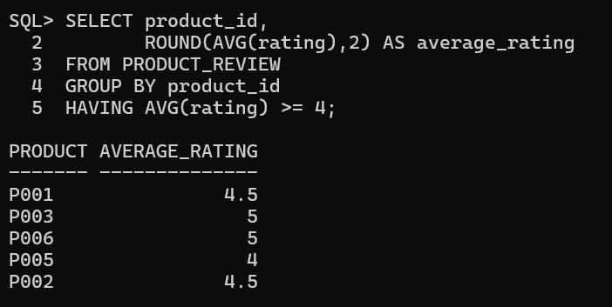

Products Requiring Improvement:
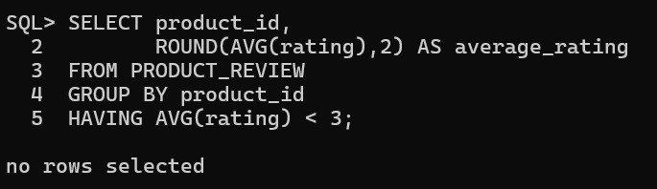

Report 3: Rating Distribution
Number of 5-Star Ratings:
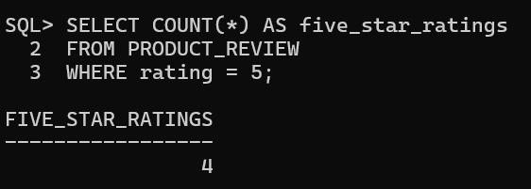

Number of 4-Star Ratings:
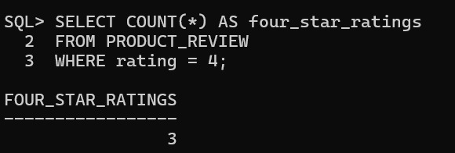
Number of Low Ratings:

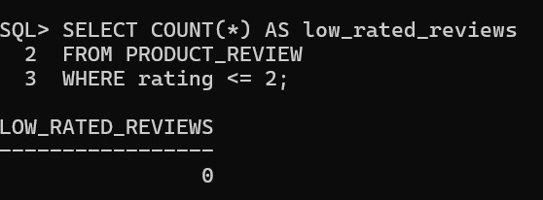
Complete Rating Distribution:
